**on** Sermon 19 Nov 2017 ‘Investing what is offered”

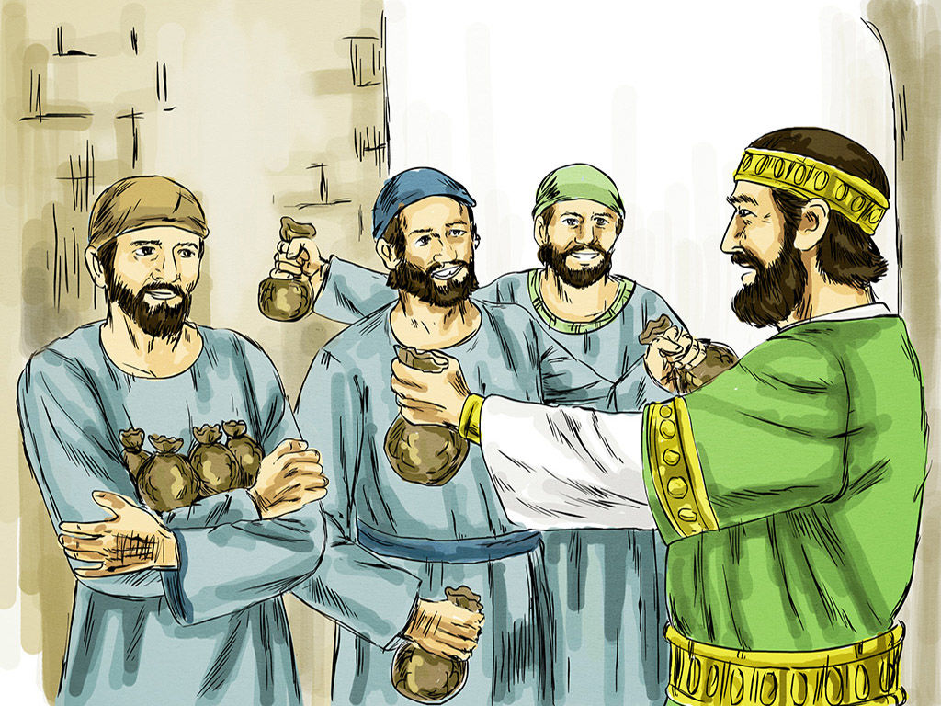

1 Thessalonians 5:1-11 Matthew 25:14-30

Prayer: God, often, despite ourselves, we rise or sink to meet high or low expectations. Help me to create high expectations for myself and others, and grant me the stamina and imagination to strive to achieve them. **Amen**. **off**

“Again, it will be like a…

**on** “Again, it will be like a…” is how our Gospel starts for us today. So what is Jesus teaching about? What *and when* is the start of the subject under discussion? What is the **“it”** that we might begin to explore Jesus words today? The context of this group of parables in Matthew is Jesus last teachings for his disciples. The **‘it’?** *Remember,* he said: “Again, **it** will be like a…”, the ‘it’ is referring ***back*** to the start of the chapter when the disciples ask Jesus when Jesus 2nd coming / ***coming back*** will happen,(vs3) when the ‘end of times’ will happen. **off And in response** Matthew presents a lot of material from Jesus including parable the 10 Bridesmaids from last week.

*So* we’re to picture Jesus in front of his disciples, responding to their questions. **on** *Last week* we reflected on Jesus teaching about the Kingdom of Heaven and with the **delay** of the bridegroom the bridesmaids had to **be ready** for the moment when God’s time **broke into** ordinary time. The ‘delay’ of Jesus into the world in the context of the Kingdom of Heaven was like a delayed bridegroom, will ***you be ready?* off**

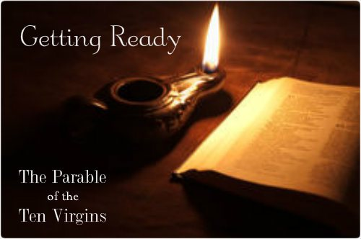

A difference for us today is that our lesson is not about the Kingdom of Heaven, 1* “This is **not a** "kingdom of heaven" parable *in other words*, **and** appears **instead** to be a continuation or commentary on the preceding parable of the *ten virgins*, the main theme of which was to address the problem of the **delay** of the bridegroom. **Here,** the main problem is similar: "...**a man went away**..."”

**Jesus** is still responding to the ‘time’ issue for his disciples, the ‘timing’ of when he would come again / back. Now for *Matthew’s listeners*, this was a crucial – vital – **very important question**. In the early days of the church we know they all thought they **would be alive** when Jesus came back – but the bridegroom hasn’t yet appeared. Remember Matthew is writing about (70-) 80 AD and Jesus was crucified in 33 AD, a bit ***of gap*** that has ***increasingly*** extended out to a few thousand years for us! Some **“delay”!**

The disciple’s question is still valid! Last week Jesus told a parable about how we were to make sure we had enough ‘oil’ on us / with us to light the path the **moment** God’s time broke into ordinary time. And remember how in the Hebrew scriptures Jesus listeners would have known ‘oil’ meant living the right way (God’s) or living into the challenge of doing ‘good-deeds’ because that’s what living God’s ways means. It is finding out about what is important for God and investing in all things ‘good’.

It means not living in ordinary time with ordinary ways, relying on current market economies at *the last minute* to provide what to do / the right way to live because Jesus said the 5 bridesmaids who did that, who did rely on ‘business-as-usual’; popping off to buy more oil, didn’t make it, they weren’t ready for the Kairos moment. They got stuck in the ‘dark’, outside, & the bridegroom didn’t know them.

It is no wonder that Paul writing for the new Christians in Thessalonica used the images, words, metaphors **that he did.** He was basing them on Jesus’s teachings! Paul was writing to them around 52AD **– much** earlier than Matthew was writing **and still** he was responding to the original disciple’s question “When will the ends times be? **on** When will Jesus come back?”



To help them, to sustain them ***‘while’*** they waited Paul used images from daily life like: light and darkness, day and night, wakefulness and sleep, sobriety and being drunk. Nothing much has changed for **us** reading his words, we get the challenge: right? We know how 2*intoxicating our ‘modern’ western society is. How easily we can be caught in the tide of “behaviours, attitudes, values systems and politics which are destructive for ourselves and others, without knowing it. Paul encourages us to stand back and recognise differences. There were pressures in his day as there are in ours. We need to keep just as awake today as they needed to then, perhaps even more so, because we are being constantly bombarded/ manipulated by subtle strategies of persuasion, "spin" of all kinds, including political "spin".” **off**

In the end the focus of Paul’s list of contrasts for us is not on heaven or eternal damnation, it is “between **sharing the life of God**, made known in Christ and dynamically present in the Spirit, *on the one hand,* and living according to the gods and priorities of greed and power, on the other.” Between the ordinary businesses of this world, or our being able to risk waiting for the good/ right word, to invest God’s way.

Paul **says this** is having 2*‘faith in the one **who gave his life** for others, who **embodied love**, and so gave people hope, which defines this ~~new~~ existence. So in 5:10 Paul takes us back again to Christ and returns to the thought of 4:17. Our future is in solidarity with Christ and that is also our hope - to live now ***and then*** with him.’ What we do **now** matters – with our life, with our faith, **how** we live.

By 5:11 Paul, knowing how important faith statements were for his people encourages the Thessalonians to support each other. In daily life that’s what matters. 2* Not much **hope** grows where not much **love** flows and **love needs** to flow through people. Paul understands this life of faith, hope, and love as one lived in community where the processes of change and renewal are generated through real experiences.”

parable-of-the-pounds-by-henry-coller

You have to live – take risks – share the Gospel of Jesus **on** and not bury it in a hole in the ground, deluding yourself it’s for the best, for protection, for safety… while you ‘wait’. In discussing this text with a colleague they passed on this piece of doggerel, it is to describe the one who will not risk!

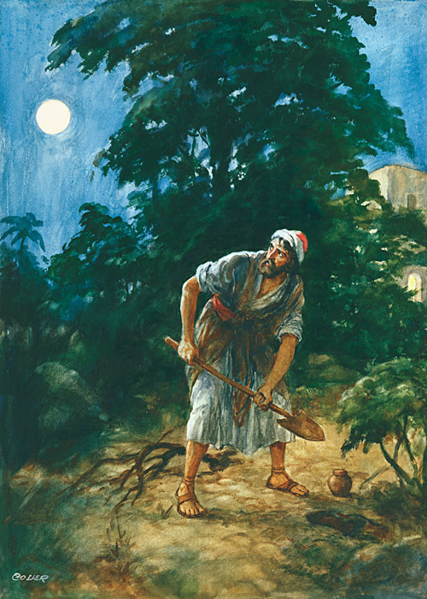

There was a very cautious man / Who never laughed or played; / He never risked, he never tried, / He never sang or prayed. / And when one day he passed away / His insurance was denied / For since he never really lived, / they claimed he never died. 3* **off**

What you **do** while you ‘wait’ matters*, Jesus said*. He taught that the man / landlord / bridegroom **is** delayed / absent, and so what you do while you wait matters – whether it is doing good deeds **or** investing your money – all of it matters. The *money part* is what Matthew covers off for us, what you do with your money matters! It has been suggested by some scholars that the ‘money’ here represents the Gospel, as I used a few sentences ago, **on** over time it has also come into western culture to mean the things you are good at doing – art, music, teaching, finances… ‘your talents’.. But initially Jesus was talking about money**. Fabulous amounts** of money **–** the 8 talents in Jesus time was worth several million dollars! **off**



But still his words are interesting, hinting at deeper meanings, the ‘man’ entrusted ‘all’ his wealth, gave them everything, **all his possessions** – and the Greek word *huperxonta*, 1*“carries the sense of possessions, yes, and also one's entire substance and even life. As soon as the man "delivers over" everything that is his, he leaves "immediately", ~~(unfortunately not translated in NRSV).~~ **He gives, and is *gone***.”

See how easy it is to put Jesus into this – his last teachings, his giving ‘all’ and going to come back *some-****when***? Of course this kind of associating only increases the tension of the parable, **and** there is no ‘final-right’ interpretation of a parable! *But back to Jesus parable*- the ‘man’ comes back and finds the first servant was a financial wizard and made millions of dollars more, the 2nd was ok –giving a decent return on the investment, but the third? **Oh my goodness!** All he did was try to protect, hide, keep safe… I’m sure all of us sympathise with him!

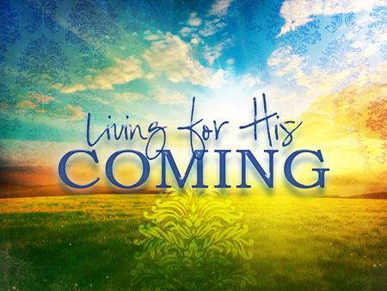

But isn’t that the point? **on** Even with our money, let alone with our faith, **and** the Gospel; hiding it, not living it, not **investing** in the right things for God, neighbour and self – is wrong and **will only** lead to increasing ‘darkness’, increasing distance from the light of Jesus path. Not investing our **‘all’**, our talents, our money, our lives in the goodness of living in the Kingdom **or** the practicing living how Jesus taught of the waiting in the now for the true living of the ‘then’, is not real living! Amen **off**